Grade 3 Parent Resource Sheet

Fraction Equivalence & Comparison

Equivalent fractions
- fractions that are equal to each other
- represent the same amount of the whole
- represent the same location on a number line

How to find equivalent fractions
- use or draw a model, like fraction bars or number lines
- use reasoning about fraction size
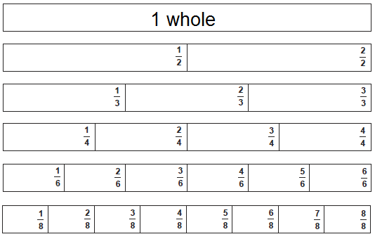
FRACTION BARS

- What fractions are equivalent to $\frac{1}{2}$ ?

- Look for fractions that line up with $\frac{1}{2}$
- Use reasoning and notice that the numerators (top) are all half of the denominators (bottom)

$\frac{1}{2}$ = $\frac{2}{4}$ = $\frac{3}{6}$ = $\frac{4}{8}$

*Grade 3 students focus on fractions with denominators of 2, 3, 4, 6 and 8.

NUMBER LINES
- What fractions are equivalent to $\frac{2}{3}$ ?
- Draw a number line with thirds.
- Use reasoning to partition each third in two parts, making sixths
- Draw another number line that’s the exact same length, marking it in sixths
- Look for fractions that line up with $\frac{2}{3}$ $\frac{2}{3}$ = $\frac{4}{6}$
- Use reasoning and notice that the numerators and denominators both doubled

Compare fractions
- Make sure that the “whole” amount is the same for each comparison
- Decide which is greater is which less and use < > symbols

How to compare fractions
- use or draw a model, like fraction bars or number lines
- use reasoning about fraction size
If the denominators are the same, reason about which is more.  $\frac{5}{6}$ > $\frac{3}{6}$  5 sixths are more than 3 sixths. | If the numerators are the same, reason about the size of the denominators.  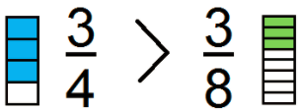  Fourths are larger pieces than eighths.

Special cases:
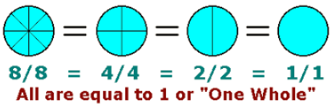
- Fractions for 1

Fractions that are equivalent to 1 mean that all the parts of the whole are shaded.

- Fractions equivalent to whole numbers

A whole number can be written as a fraction with a denominator (bottom) of 1. The denominator of 1 means that the whole has not been cut into parts.
EX: $\frac{2}{1}$ is read as “two wholes” and is equivalent to 2.
Learnzillion: https://learnzillion.com/lesson_plans/8304-express-whole-numbers-as-fractions
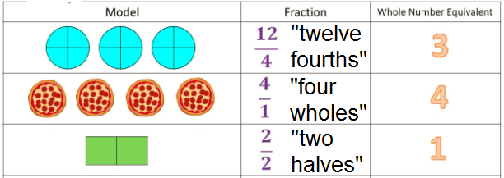

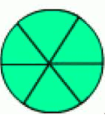
You try it: What fractions are shown here?
- B) C) D)

Answers A) $\frac{6}{6}$ B) $\frac{3}{1}$ C) $\frac{5}{5}$ D) $\frac{5}{1}$

