Grade 3 – Parent Resource Sheet – Understanding Area
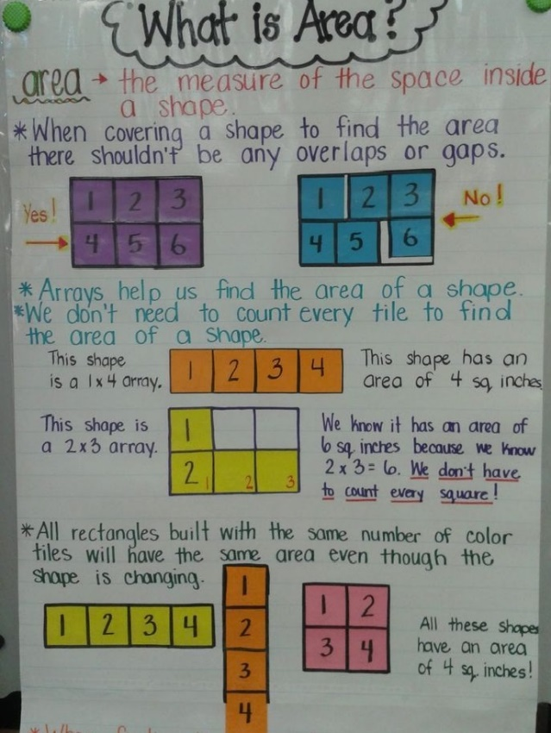
In third grade, students will develop an understanding of using square units to measure area. They also learn about area as the amount of surface and count unit squares needed to cover a surface to determine areas of figures. They will connect area to multiplication. Students will decompose rectangles and recognize that complex shapes can be decomposed into smaller shapes to calculate area.

The following vocabulary is important for understanding area:
area: the measure of the space inside a shape. We calculate the area by multiplying the length x width.
factors: numbers we can multiply together to get another number (the product)
product: the answer to a multiplication equation
length: the distance from one point to another (to find area it is a side.)
square unit: a unit of measurement that determines the area of a plane figure
width: one dimension (side) of a plane figure.

